**MY SQL PROJECT: SECONDHAND CAR DEALER**

* Read Car data.
* Total Cars: To get a count of total records.
* The manager asked the employee how many Cars will be available in 2023?
* The manager asked the employee how many Cars will be available in2020, 2021,2022?
* Clints asked to print the total of Cars by year. I did not see all the details.
* Clint asked to Car dealer agent how many Diesels Car will be there in 2020?
* The manager told the employee to give a print of all fuel Cars (petrol, diesel, and CNG) come by all year.
* The manager said there were more than 100 Cars in given year which year had more than 100 Cars?
* The manager said to the employee All Cars count details between 2015 to 2023; we need complete list.
* The manager said to the employee All Cars details between 2015 to 2023 we need complete list.

1. **Read Car Data**:
   * Import the car data from your dataset.
   * Ensure the data is loaded correctly.

SELECT*FROM car_dekho;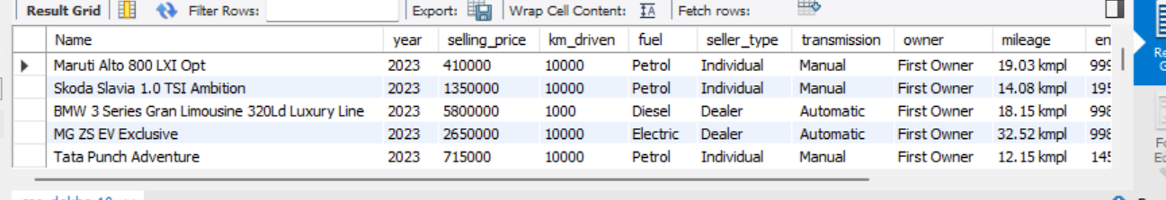

1. **Total Cars**:
   * Calculate the total number of car records in the dataset.

SELECT COUNT(*) FROM car_dekho;

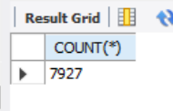

1. **Cars Available in 2023**:
   * Determine how many cars will be available in the year 2023.

SELECT COUNT(*) FROM car_dekho WHERE YEAR = 2023;

1. **Cars Available in 2020, 2021, and 2022**:
   * Find the count of cars available in each of these years.

SELECT COUNT(*) FROM car_dekho WHERE YEAR IN (2020,2021,2022) group by YEAR;

SELECT COUNT(*) FROM car_dekho WHERE YEAR = 2020;

SELECT COUNT(*) FROM car_dekho WHERE YEAR = 2021;

SELECT COUNT(*) FROM car_dekho WHERE YEAR = 2022;

1. **Total Cars by Year**:
   * Summarize the total number of cars by year.

select year, count(*) from car_dekho group by year;

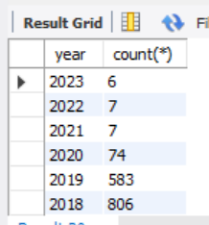

1. **Diesel Cars in 2020**:
   * Identify the count of diesel cars specifically for the year 2020.

select count(*) from car_dekho where year = 2020 and fuel = "diesel";

1. **Fuel Types (Petrol, Diesel, CNG) Across All Years**:
   * Print the total count of cars for each fuel type (petrol, diesel, and CNG) across all years.

select year, count(*) from car_dekho where fuel = "petrol" group by year;

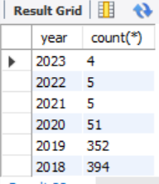

select year, count(*) from car_dekho where fuel = "diesel" group by year;

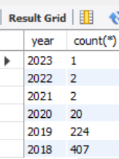

select year, count(*) from car_dekho where fuel = "cng" group by year;

1. **Year with More Than 100 Cars**:
   * Determine which year had more than 100 cars.

select year, count(*) from car_dekho group by year having count(*)>100;

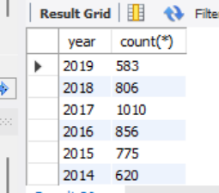

1. **All Cars Count Details (2015 to 2023)**:
   * Provide a complete list of car counts for each year between 2015 and 2023.

select COUNT(*) FROM CAR_DEKHO where YEAR between 2015 AND 2023;

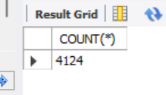

1. **All Cars Details (2015 to 2023)**:
   * Create a comprehensive list of all car details within the specified time frame.

select*FROM car_dekho WHERE YEAR between 2015 AND 2023;

